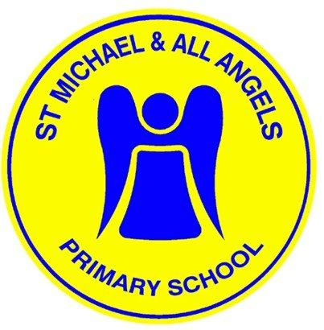
St Michael and All Angels
Quality of Education
Terms of Reference
2023-24
As members of the Governing Body of SMAAA we pledge to:
Follow the Seven Principles of Public Life outlined by Lord Nash including:
- selflessness;
- integrity;
- objectivity;
- accountability;
- openness;
- honesty;
- leadership.
We will also:
Area | Responsibilities
Organisation and teamwork | - review the terms of reference for this committee;  - set out a monitoring plan annually;  - participate in training;  - agree to use the Nolan principles of public office;  - review / make recommendations for policies with key staff.
Recruitment and retention/ communicate with parents/carers | - contribute to the School Development Plan;  - contribute to the schools Self-evaluation;  - review and contribute to the enhancement of reports to parents;  - contribute to the school prospectus;  - actively engage with the School Council and other groups of pupils;  - engage with parents through questionnaires and surveys.
Strategic Leadership and Statutory Responsibilities | - be responsible for the leadership of specific activities;  - promote individual learning and well being;  - participate in Performance Management process.
Strengths and Weaknesses/Self-Review and Change | - use a variety of information including Raiseonline, Family Fischer Trust and attendance to review the provision in the school;  - read and evaluate case studies;  - contribute and participate in teaching development and pupil work;  - attend school events;  - follow up on proposed actions.
Support and Challenge | - work with staff and other Governors;  - promote the good reputation of the school;  - ask questions and ensure that challenges are followed through;  - engage with the school leadership team.
Impact/including school improvement/pupil safety and well being/partnerships and community engagement | - we will identify a priority that will improve outcomes for pupils;  - we will decide what to do;  - we will review what action the school took;  - we will review the impact;  - we will review the lessons that we learned.
Membership and Meetings of the Teaching & Learning Committee
- there will be a minimum of three Governors plus the Headteacher;
- this committee will meet on at least three occasions per academic year i.e. once per term;
- this Committee will be Chaired by ........................................ during the academic year 2023-24
Quorum
- Three members of the committee including the Headteacher or in his/her representative.
Terms of reference
We will :
Area | Responsibilities
Teaching, Learning and Assessment | - monitor and evaluate rates of progress and standards of achievement of pupils including any underachieving groups;  - to support SLT when setting Key Stage targets;  - check annually that arrangements are in place to ensure that all statutory assessments are conducted appropriately, and that the results are forwarded to parents/carers, and that for each pupil the parents/carers receive an annual progress/achievement report;  - review the school’s pastoral support and safeguarding procedures;  - monitor pupil behaviour and attendance particularly those who are persistently absent and what action has been taken, especially the most vulnerable pupils;  - ensure that pupils are encouraged to keep themselves safe, including helping pupils adopt safe and responsible practices and deal sensibly with risk;  - monitor and evaluate the impact of improvement plans;  - monitor how the curriculum is delivered, resourced and evaluated;  - monitor and evaluate the impact of quality of teaching on rates of pupil progress and standards of achievement including feedback and assessment;  - ensure that the requirements of children with special educational needs are met, as laid out in the Code of Practice, and receive termly reports from the SENCO;  - consider recommendations from external reviews of the school (e.g. Ofsted, LA etc);  - ensure that all pupils have equal opportunities;  - identify and celebrate pupil achievements;  - ensure the school encourages all pupils to develop their personal, development and behavioural cultures;  - promote a culture of enabling staff and pupils to excel;  - track cohorts of pupils (all groups) and prepare with key staff case studies;  - work with key staff to prepare drafts for approval of the Full Governing Body- School Development Plan, Mission Statement, Prospectus, Policy Statements for each area of the curriculum, curriculum aims (Review these documents);  - prepare the School Prospectus with key staff for the approval of the Governing Body  - make recommendations to the Resource Management Committee on resource levels for curriculum implementation;  - provide information to the Governing Body on how assessment information gathered is used to plan appropriate teaching and learning enabling excellent progress;  - recommend challenging targets for cohorts;  - ensure British Values are at the heart of the schools work;  - positively engage with the parents/carers ;  - provide information to the Governing Body on teaching an its’ effectiveness;  - ensure that staff are given the opportunity to reflect on how they teach;  - equal opportunities and the recognition of diversity are promoted through excellent teaching and learning, and  - ensure teachers set challenging homework
Personal development,  behaviour and | - ensure pupils social, moral, spiritual and cultural development is promoted across the curriculum;  - make recommendations to the Governing Body to protect pupils from radicalisation and extremism;  - make recommendations and work with key staff to promote Safeguarding through curriculum;  - ensure pupils are happy, confident and positive learners who are proud of their achievements;  - promote good attendance that is constantly improving;  - work with key staff to maintain impeccable behaviour for behaviour;  - ensure pupils work hard with the school to prevent all forms of bullying;  - ensure pupils are confident that their voice is heard when concerns are raised about bullying, racism or cyber bulling;  - ensure pupils feel safe at all times;  - ensure all groups of pupils are healthy, fit and know how to make choices about their emotional and mental well being, and  - guide all groups of pupils to develop their responsibility to the wider community.

