

St Michael and All Angels Catholic Primary School

NEWSLETTER

Friday 9th February 2024

Highlights



This week everyone has been busy learning in many ways.

Year 2/4/6 have had the best time in PE with Lisa and the great dance lessons that she leads. There are some great moves and routines being developed. Well done everyone.

It is great when children take part in PE. Please remember that the school PE kit is a yellow T-shirt/ royal blue shorts or tracksuit bottoms. Children should also wear their school jumper on PE days rather than a branded track suit top.

Key Stage 2 children have been working with the Liverpool Academy on developing local community projects. Year 5 have chosen caring for animals. I wonder what the other year groups have chosen?

Dates For Your Diary

Fri 9th Feb- School Closes for Half-Term

Mon 12th Feb- Attendance Support Meetings for families

Fri 23rd  Feb- School Photographs (Nur to Yr 6)

Dates for class services during Lent will be distributed soon

Wk beg 4th March -Open Afternoon Nur to Year 6

Wednesday Word

**e-bug learning**

**Dental Hygiene**

Take a look at this free event taking place over the weekend.

**Attendance**

Ensuring children are in school every day is crucial to their education. Being off regularly not only impacts their academic progress but can present problems with establishing good relationships as well. It is imperative that children are in school, enjoying being with their friends and learning every day. Please follow this link for information about [Educational Penalty Notices](https://www.smaaaprimary.co.uk/serve_file/20362549)

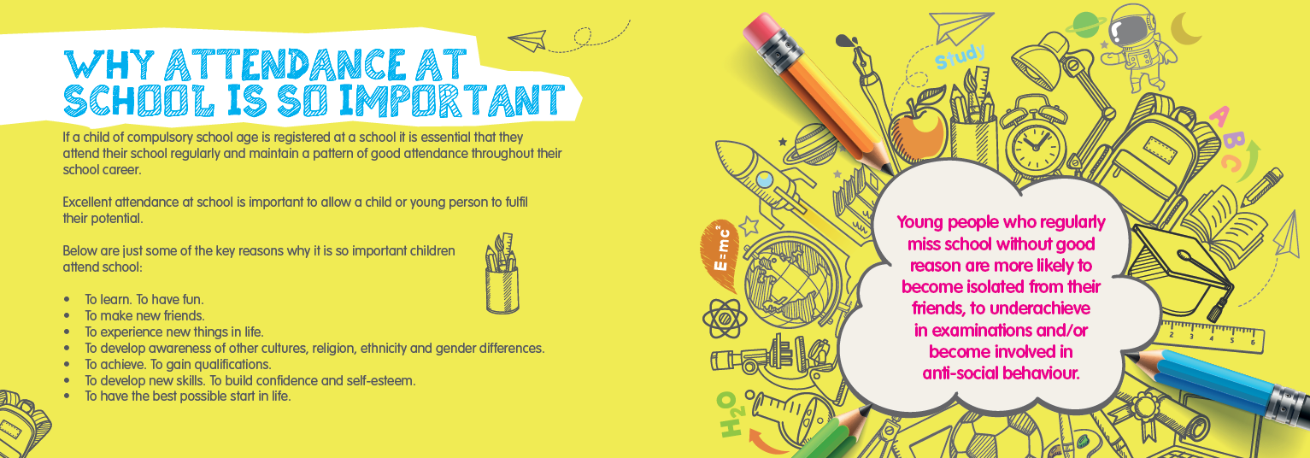

**Weekly Awards**

Staying Safe Online

How well do you understand the online platforms your children are using?

Click [here](https://www.nspcc.org.uk/keeping-children-safe/online-safety/social-media/) to find out more about Snapchat, Tik Tok and more.

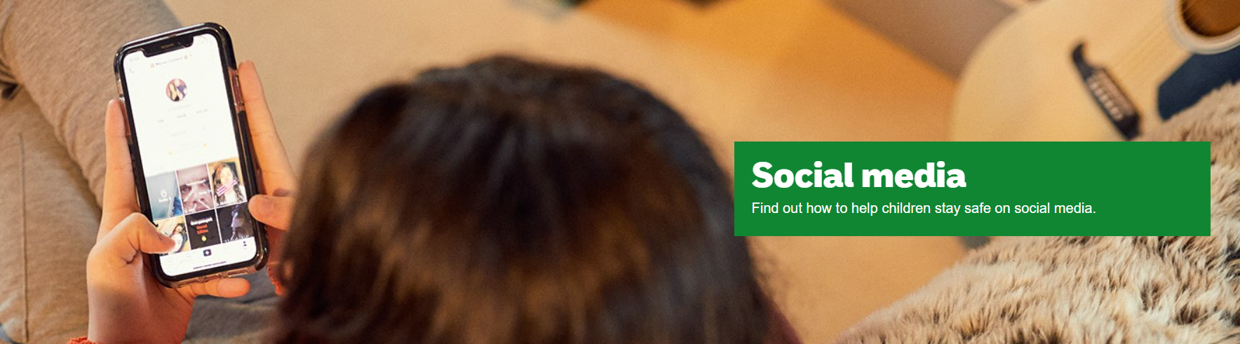

Attendance

Highest attendance this week was:

Class 7 Year 3

96.7%

Well done everyone!



What current events have we been discussing in school this week? Ask your child to tell you all about their discussion about this picture from the news this week…

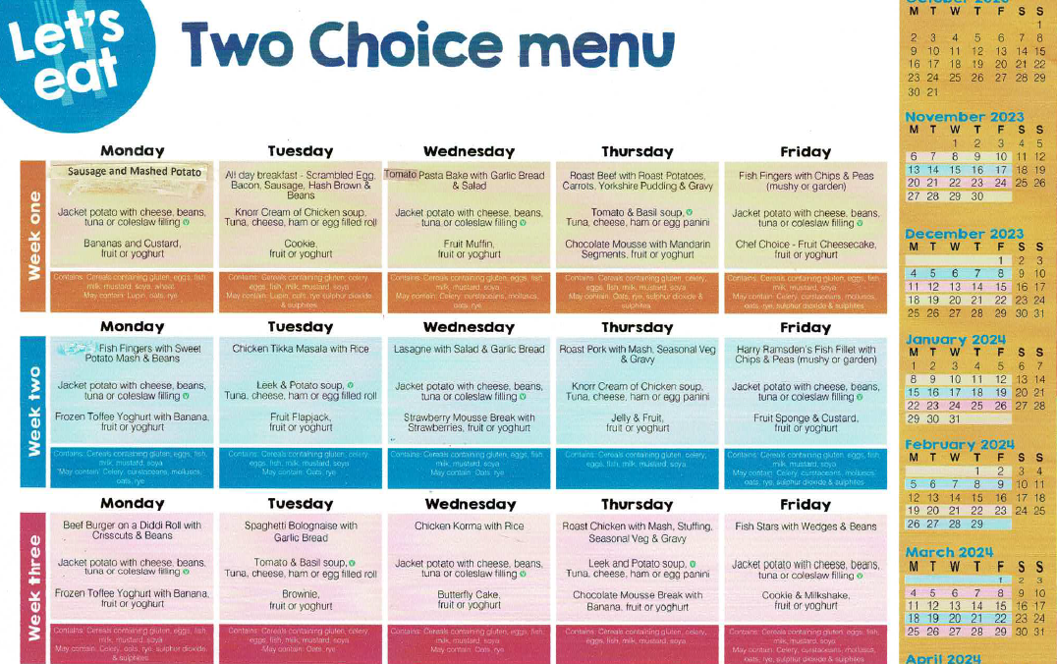

Weekly Awards…well done everyone.

