Calculation Policy: Subtraction
Key language: take away, less than, the difference, subtract, minus, fewer, decrease
Key representations: place value counters, base 10, bead strings, multilink, counters, Numicon, bar model, number line
Concrete | Pictorial | Abstract
Physically taking away and removing objects from a whole (ten frames, Numicon, cubes and other items such as beanbags could be used).  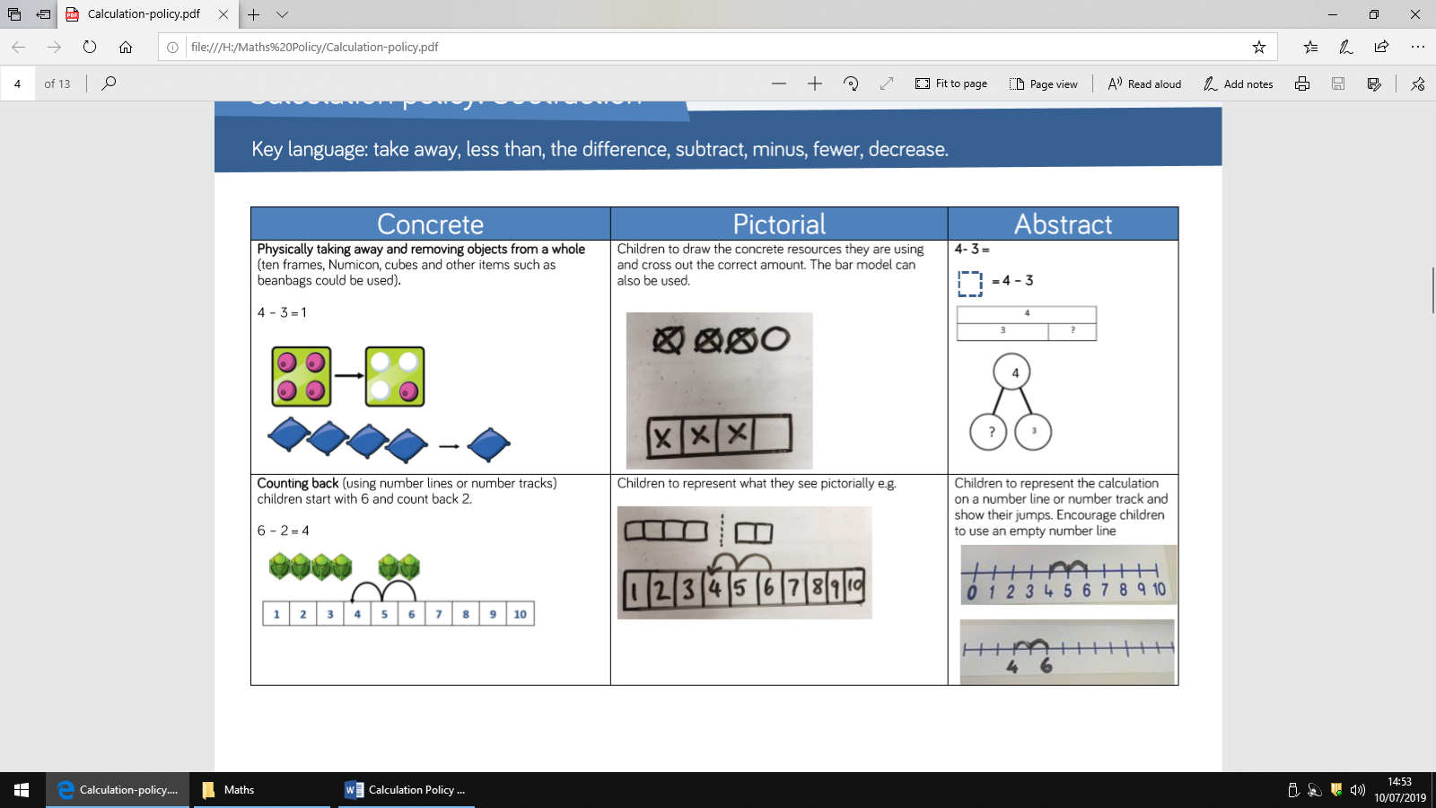 | 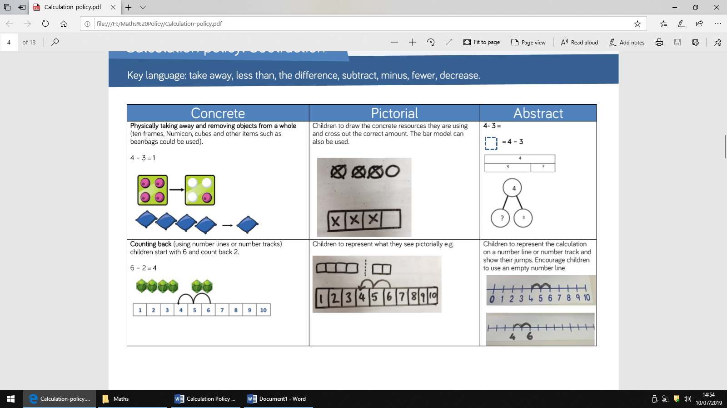  Children to draw the concrete resources they are using and cross out the correct amount. The bar model can also be used. | 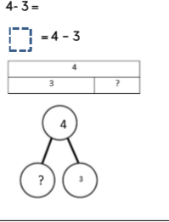
Counting back  The children will start at 6 and count back 2.  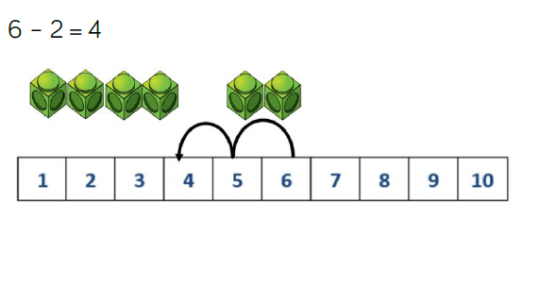 | 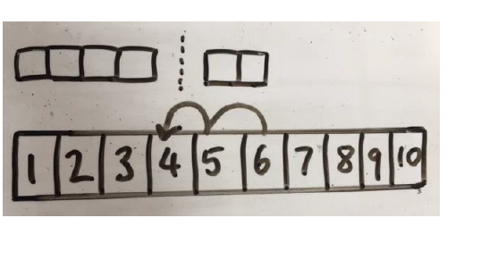  Children will then draw their own representations of what they see. | 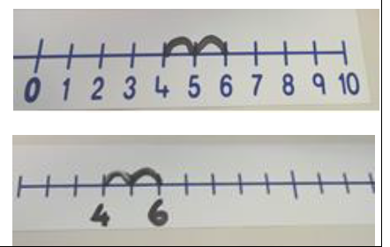  Children to represent the calculation and show their jumps. Children will be encouraged to use and empty number line.
Finding the difference  Calculate the difference between 8 and 5.  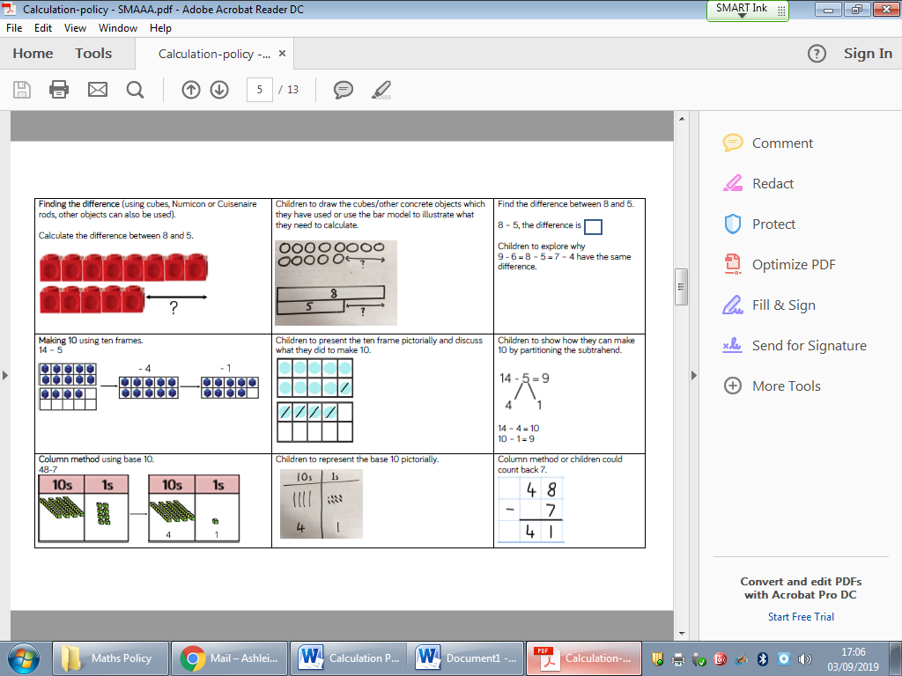 | Children to draw the objects which they have used to illustrate what they need to calculate.  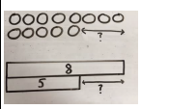 | 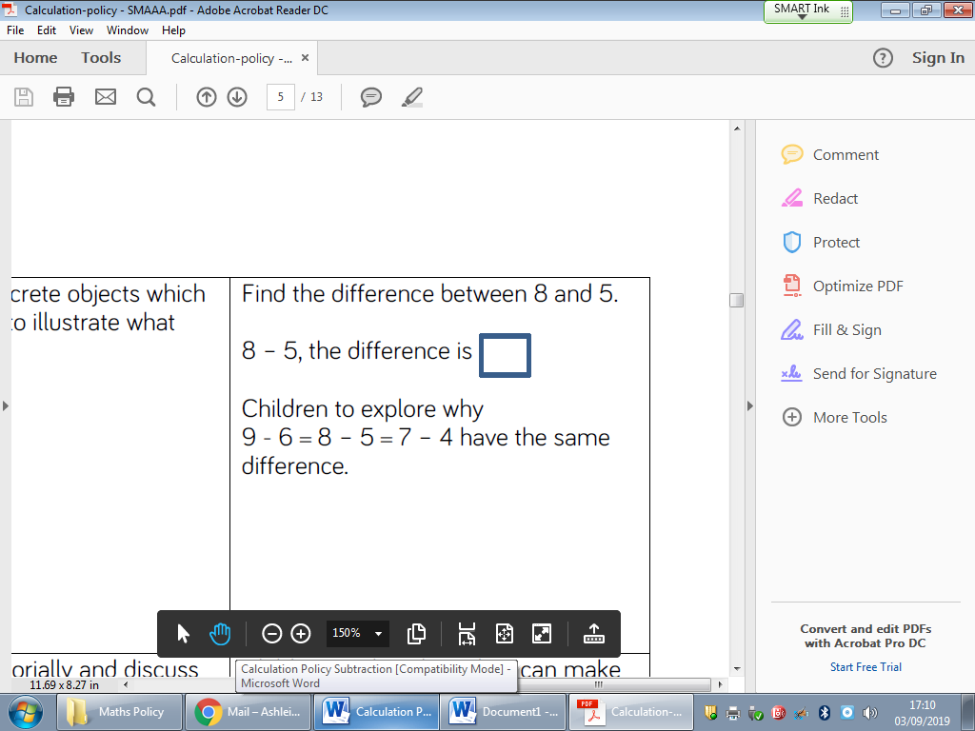
Making 10 using ten frames.  14-5  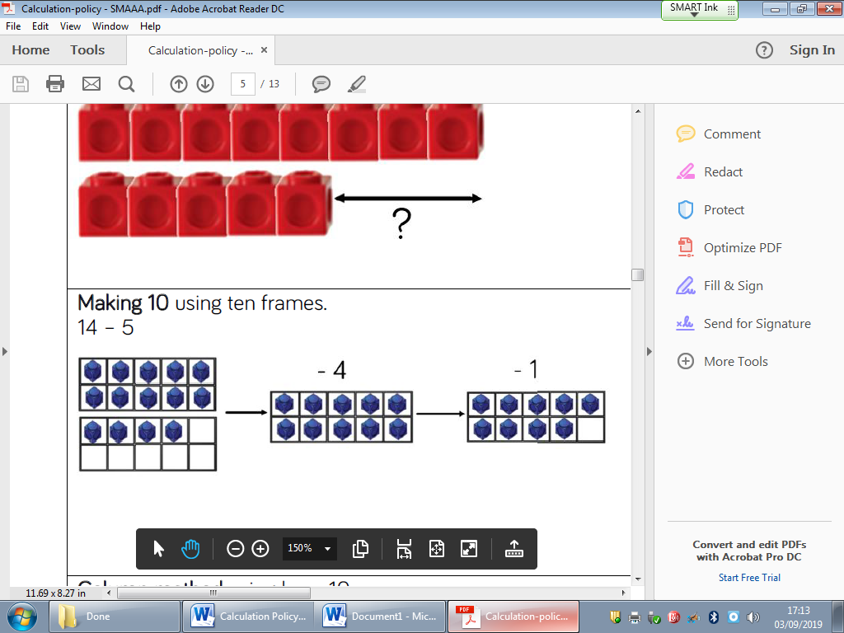 | 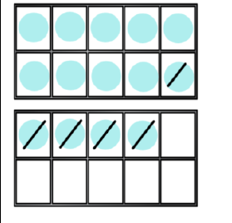  Children to complete their own ten frame and discuss what they did to make 10. | Children to show how they can make ten by portioning the subtrahend.  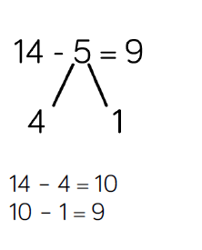  Subtrahend- a quantity or number to be subtracted from another.
Using base ten  48-16=  Children to use base ten to partition 48.  48-16=  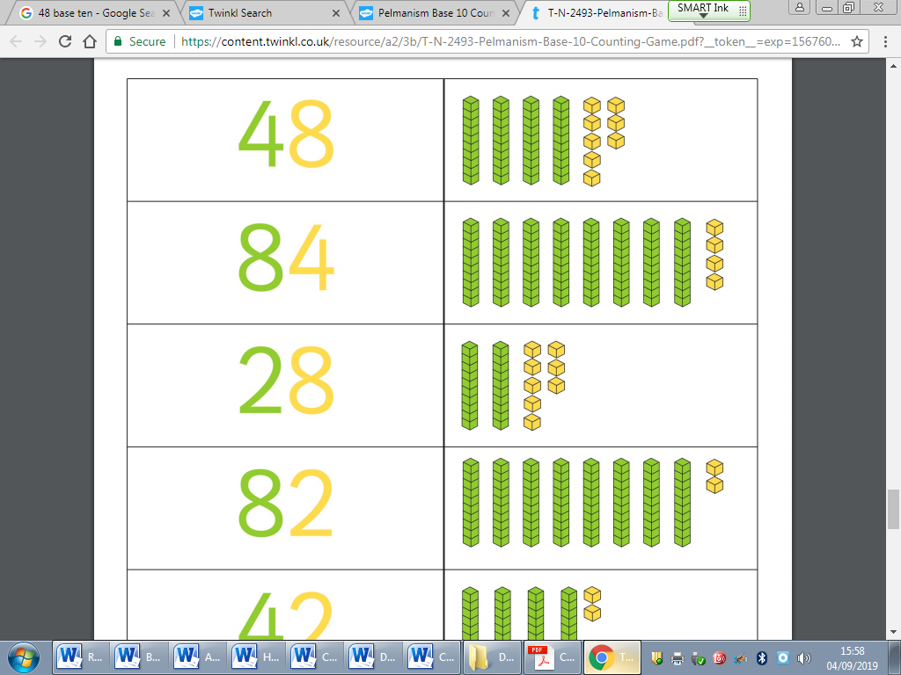 | Children to represent tens and ones pictorally. Lines to represent tens and dots/squares to represent one.  48-16= | 48-16=  4 tens subtract 1 ten equals  8 ones subtract 6 ones equals

Column method using base 10 an having to exchange.  41-26=  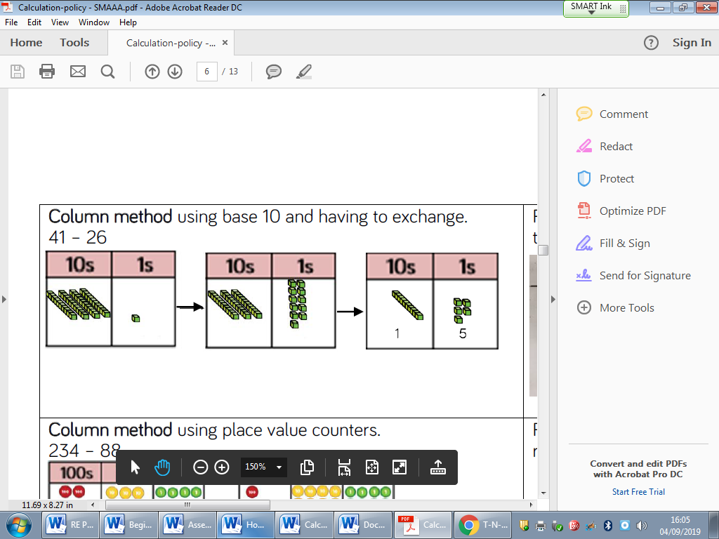 |  | Formal column method. Children must understand that when they have exchanged the 10 they still have 41 because 30+11=41.  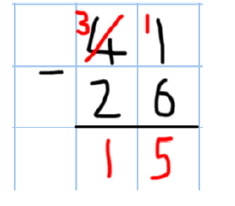
Column method using place value counters.  234-88=  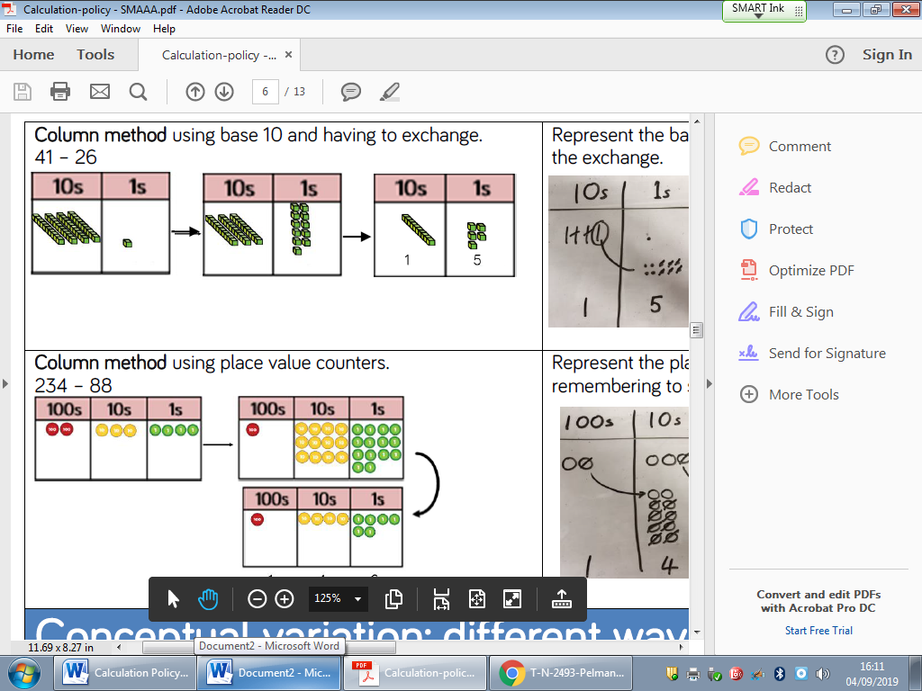 |  | 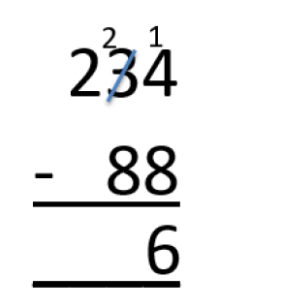  Formal column method. Children must understand what has happened when they have crossed out digits.

