St. Michael &
All Angels Primary School

This policy was adopted on | Date: July 2022  Review Date : Sept 2023
By Name: | Fr A Rowlands
Position: | Chair of Governors
Signature: | on behalf of St Michael & All Angels Primary School

Personal, Social and Health Education Statement

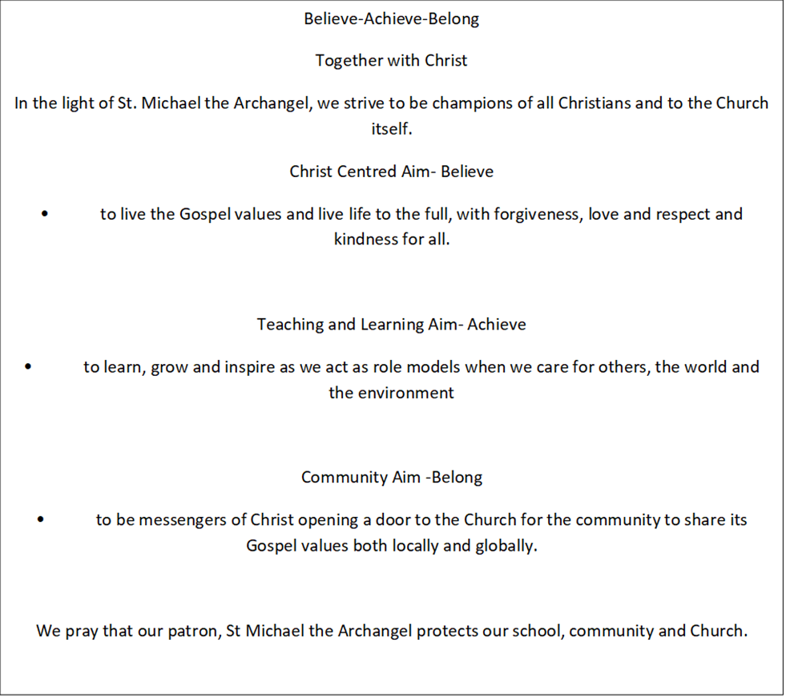

Aim
St Michael and All Angels Catholic Primary School we believe that PSHE education and citizenship enables children to become heathier, more independent and more responsible members of society. We encourage our pupils to play a positive role in contributing to the life of the school and the wider community. In doing so, we help our children to develop their sense of self-worth. We teach them how society is organised and governed. We ensure that the children experience the process of democracy through participation in school councils etc. We teach children about their rights and about their responsibilities. They learn to appreciate what it means to be a positive member of a diverse and multi-cultural society.
Objectives
- to know and understand what is meant by a healthy lifestyle;
- be aware of safety issues;
- understand what makes for good relationships with others;
- have respect for other people and show sensitivity towards others;
- be thoughtful and responsible members of their community and school;
- become active members of our democratic society;
- develop self-confidence and self-esteem;
- make informed choices regarding personal and social issues;
- develop good relationships with other members of the community.
Teaching and Learning
Through embedding high quality PSHE experiences within the school day and making purposeful links with their subjects PSHE learning will equip our children to deal with life’s daily challenges by:
- using a range of teaching and learning strategies;
- making links with other curriculum areas;
- emphasis problem solving and investigations;
- promote charity and fund raising activities (local and global);
- participate in circle time and PSHE SEAL lessons;
- make links with local visiting speakers e.g. Parish Priest , community police, school nurse or health teams and other local schools;
- celebrate achievements across all Key Stages.
Curriculum Planning
- organise PSHE in an age related curriculum;
- ensure that all areas of PSHE curriculum is covered annually;
- ensure curriculum maps are available for parents or carers on the website;
- follow the SEAL topic themes consistently;
- make links between the PSHE topic and RE Come and See topics;
- plan whole events for each term e.g. Anti- Bullying Week, Online Safety or Fairtrade;
- make global links;
PSHE and Inclusion
We teach PSHE and Citizenship to all children, regardless of their ability and needs. Our teachers provide learning opportunities matched to the individual needs of the child. When planning for an inclusive PSHE curriculum the teacher will take into consideration the individual and groups targets with that group or class.

Assessment
At St Michael and All Angels we will:
- use the year group assessment sheets to gather evidence of pupil progress within PSHE;
- share progress on termly meetings with parents or carers and on End Of Year Reports;
- enable pupils to reflect on their learning and progress and comment on their End of Year report;
- observe PSHE skills within lesson observations throughout the year.
Role of the Governors
- to review the PSHE Policy following the Policy Review Cycle;
- receive an End of Year Report from the PSHE Subject Leader;
- receive and monitor annual PSHE curriculum maps.

